AI ASSISTED CODING (ASSIGNMENT-12.1)
NAME: T. Vamsi Krishna
ROLL NO: 2503A52705
BATCH: 24

#Q1.
TASK: Insertion Sort – Employee Salary Management
A company maintains employee salary records. The system needs to
arrange salaries in ascending order.
• Write a program to implement Insertion Sort.
• Explain the role of the key element and shifting operations.
• Display the array after each iteration.
• Analyze the algorithm&#39;s efficiency for nearly sorted data.
PROMPT: Write a simple Python program to sort employee salaries in ascending order using Insertion Sort. Display the array after each iteration and explain the key element, shifting operations, and time complexity for nearly sorted data.
CODE:

n = int(input("Enter number of employees: "))

salaries = []

for i in range(n):
salary = int(input("Enter employee salary: "))
salaries.append(salary)

print("Original Salaries:", salaries)

# Insertion Sort
for i in range(1, n):
key = salaries[i]
j = i - 1

while j >= 0 and salaries[j] > key:
salaries[j + 1] = salaries[j]
j -= 1

salaries[j + 1] = key

print("After iteration", i, ":", salaries)

print("Sorted Salaries:", salaries)
OUTPUT:
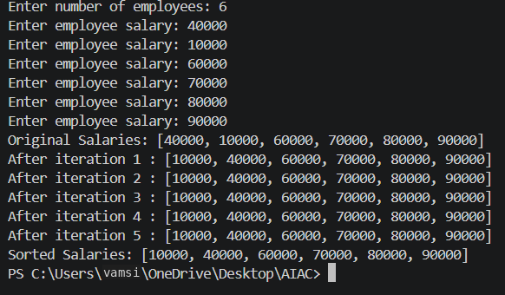
#Q2.
TASK: Question 2: Merge Sort – Hospital Patient Records
A hospital maintains thousands of patient records containing Patient
ID, Patient Name, and Medical Bill Amount.
• Write a program to implement Merge Sort to arrange patient
records based on bill amount.
• Demonstrate the divide-and-conquer process.
• Show the splitting and merging operations.
• Analyze the time and space complexities.
PROMPT: Write a simple Python program using Merge Sort to arrange hospital patient records based on medical bill amount. Include Patient ID, Patient Name, and Bill Amount. Display splitting and merging operations and explain time and space complexity.
CODE:

# Merge Sort - Hospital Patient Records

def merge_sort(records):
if len(records) <= 1:
return records

mid = len(records) // 2

print("\nSplitting:", records)

left = merge_sort(records[:mid])
right = merge_sort(records[mid:])

merged = []

while left and right:
if left[0][2] <= right[0][2]:
merged.append(left.pop(0))
else:
merged.append(right.pop(0))

merged.extend(left)
merged.extend(right)

print("Merging:", merged)

return merged

# Get patient details from user
n = int(input("Enter number of patients: "))

patients = []

for i in range(n):
print("\nEnter details of Patient", i + 1)

patient_id = int(input("Enter Patient ID: "))
name = input("Enter Patient Name: ")
bill = float(input("Enter Medical Bill Amount: "))

patients.append([patient_id, name, bill])

print("\nOriginal Patient Records:")
for p in patients:
print(p)

# Sort records by bill amount
sorted_patients = merge_sort(patients.copy())

print("\nSorted Patient Records (By Bill Amount):")
for p in sorted_patients:
print("ID:", p[0], "| Name:", p[1], "| Bill:", p[2])
OUTPUT:
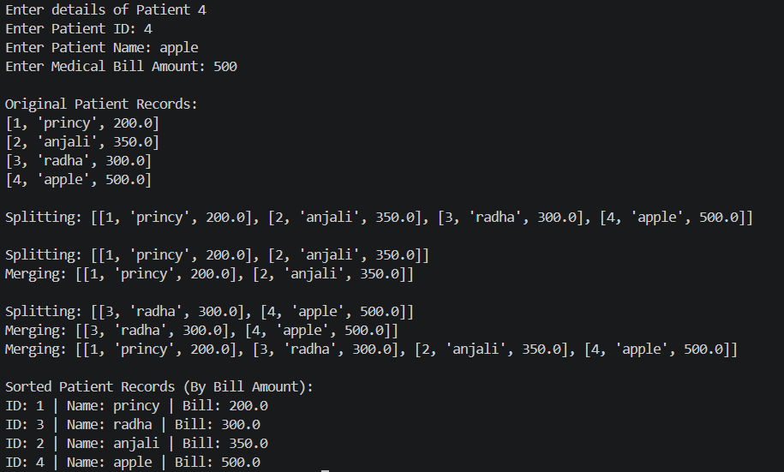
#Q3.
TASK: Selection Sort – Product Price Management
An online shopping platform maintains a list of product prices.
• Write a program to implement Selection Sort to arrange
product prices in ascending order.
• Identify the minimum element in every pass.
• Display the array after each pass.
• Analyze the time and space complexities.
PROMPT: Write a simple Python program using Selection Sort to arrange product prices in ascending order. Take prices as user input, identify the minimum element in each pass, display the array after every pass, and explain time and space complexity.
CODE:

# Selection Sort - Product Price Management

n = int(input("Enter number of products: "))

prices = []

for i in range(n):
price = float(input("Enter product price: "))
prices.append(price)

print("\nOriginal Product Prices:", prices)

for i in range(n):
min_index = i

# Find minimum element
for j in range(i + 1, n):
if prices[j] < prices[min_index]:
min_index = j

# Swap minimum element
prices[i], prices[min_index] = prices[min_index], prices[i]

print("After Pass", i + 1, ":", prices)

print("\nSorted Product Prices:", prices)
OUTPUT:
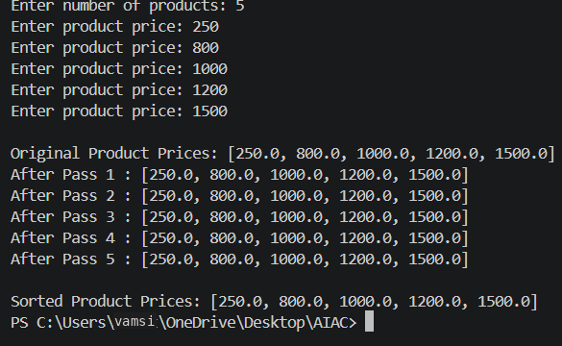
#Q4.
TASK: Bubble Sort – Student Marks Sorting
A university maintains student records containing Roll Number,
Student Name, and Marks.
• Write a program to implement Bubble Sort to arrange
students in ascending order of marks.
• Display the array after each pass.
• Explain the swapping process.
PROMPT: Write a simple Python program using Bubble Sort to arrange student records in ascending order of marks. Take Roll Number, Student Name, and Marks as user input. Display the records after each pass and explain the swapping process.
CODE:

# Bubble Sort - Student Marks Sorting

n = int(input("Enter number of students: "))

students = []

for i in range(n):
print("\nEnter details of student", i + 1)

roll = int(input("Enter Roll Number: "))
name = input("Enter Student Name: ")
marks = float(input("Enter Marks: "))

students.append([roll, name, marks])

print("\nOriginal Student Records:")
for s in students:
print(s)

# Bubble Sort
for i in range(n - 1):
for j in range(n - i - 1):

if students[j][2] > students[j + 1][2]:
students[j], students[j + 1] = students[j + 1], students[j]

print("\nAfter Pass", i + 1)
for s in students:
print(s)

print("\nStudents Sorted by Marks:")
for s in students:
print("Roll No:", s[0], "| Name:", s[1], "| Marks:", s[2])
OUTPUT:
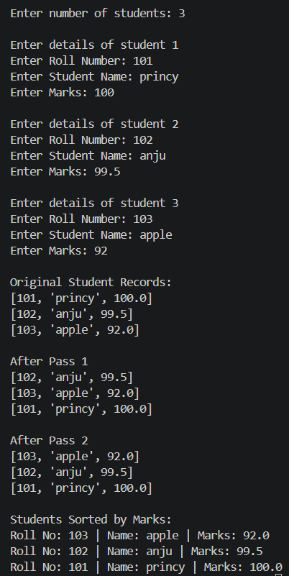
#Q5.
TASK: Quick Sort – Examination Result Processing
A university maintains examination results containing Roll Number,
Student Name, and Total Marks.
• Write a program to implement Quick Sort to arrange students
in descending order of marks.
• Select the last element as the pivot.
• Explain the partitioning process and recursive calls.
• Analyze the best, average, and worst-case time complexities.
PROMPT: Write a simple Python program using Quick Sort to arrange student records in descending order of marks. Take Roll Number, Student Name, and Total Marks as user input. Select the last element as the pivot and display the partitioning process.
CODE:

# Quick Sort - Examination Result Processing

def partition(students, low, high):
pivot = students[high][2]
i = low - 1

for j in range(low, high):
if students[j][2] >= pivot:
i += 1
students[i], students[j] = students[j], students[i]

students[i + 1], students[high] = students[high], students[i + 1]

print("Pivot:", pivot)
print("After Partition:", students)

return i + 1

def quick_sort(students, low, high):
if low < high:
pi = partition(students, low, high)

quick_sort(students, low, pi - 1)
quick_sort(students, pi + 1, high)

# Get student details
n = int(input("Enter number of students: "))

students = []

for i in range(n):
print("\nEnter details of student", i + 1)

roll = int(input("Enter Roll Number: "))
name = input("Enter Student Name: ")
marks = float(input("Enter Total Marks: "))

students.append([roll, name, marks])

print("\nOriginal Student Records:")
for s in students:
print(s)

quick_sort(students, 0, n - 1)

print("\nStudents Sorted by Marks (Descending):")
for s in students:
print("Roll No:", s[0], "| Name:", s[1], "| Marks:", s[2])
OUTPUT:


